Authentication of Product & Counterfeits Elimination Using Blockchain

In this paper author is using Blockchain technology to authenticate supply chain products as this products may be supplied from multiple third party distributors and this distributors can make clone/fake/counterfeits of this product BAR CODE and then manufacture fake products and add this counterfeit label to fake product and this fake products can cause huge loss of financial and lives if fake medicine manufacture.

Not only supply chain any other online transaction require third party to complete transaction and peoples has to trust on third parties to complete their transaction and sometime this third parties can make fraud transaction or misuse user data.

To avoid this problem author using Blockchain technology which does not require any third party and verification will be done by software algorithm itself without involvement of any third party. In this to avoid forge counterfeit we are converting all products details/barcode into digital signatures and this digital signatures will be stored in Blockchain server as this Blockchain server support tamper proof data storage and nobody can hack or alter its data and if by an chance if its data alter then verification get failed at next block storage and user may get intimation about data alter.

In Blockchain technology same transaction data stored at multiple server with hash code verification and if data alter at one server then it will detected from other server as for same data hash code will get different. For example in Blockchain technology data will be stored at multiple servers and if malicious users alter data at one server then its hash code will get changed in one server and other servers left unchanged and this changed hash code will be detected at verification time and future malicious user changes can be prevented.

In supply chain also all products barcode digital Blockchain signatures will be stored and if any third party distributor make clone of barcode then its signature will be mismatch and counterfeit will be detected

In Blockchain each data will be stored by verifying old hash codes and if old hash codes remain unchanged then data will be consider as original and unchanged and then new transaction data will be appended to Blockchain as new block. For each new data storage all blocks hash code will be verified.

In this project we have designed following modules

1. Save Product with Blockchain Entry: In this module user will enter product details and then upload product bar code image and then digital signature will be generated on uploaded barcode and then this transaction details will be store in Blockchain. Before storing transaction Blockchain will verify all old transaction and upon successful verification new transaction block will be store
2. Retrieve Product Data: Using this module user can search existing product details by entering product id
3. Authenticate Scan: Here in this module we don’t have any scanner so we are uploading original or fake bar code images and then Blockchain will verify digital signature of uploaded bar code with already store bar codes and if match found then Blockchain will extract all details and display to user else authentication will be failed.

To design Blockchain database and storage we have written following code and in below screen shots read red colour comments to understand Blockchain code

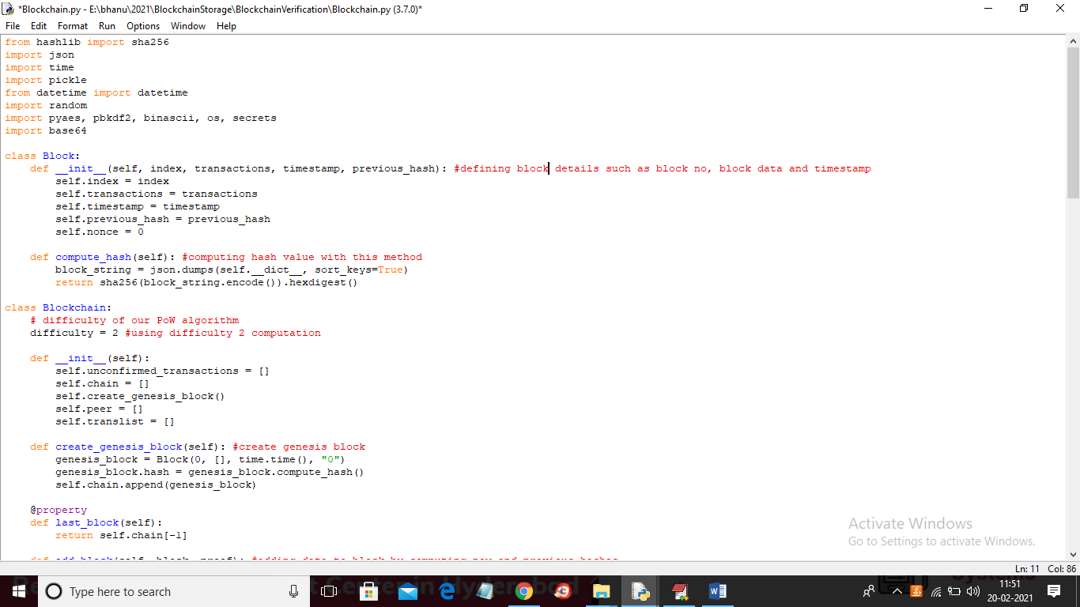

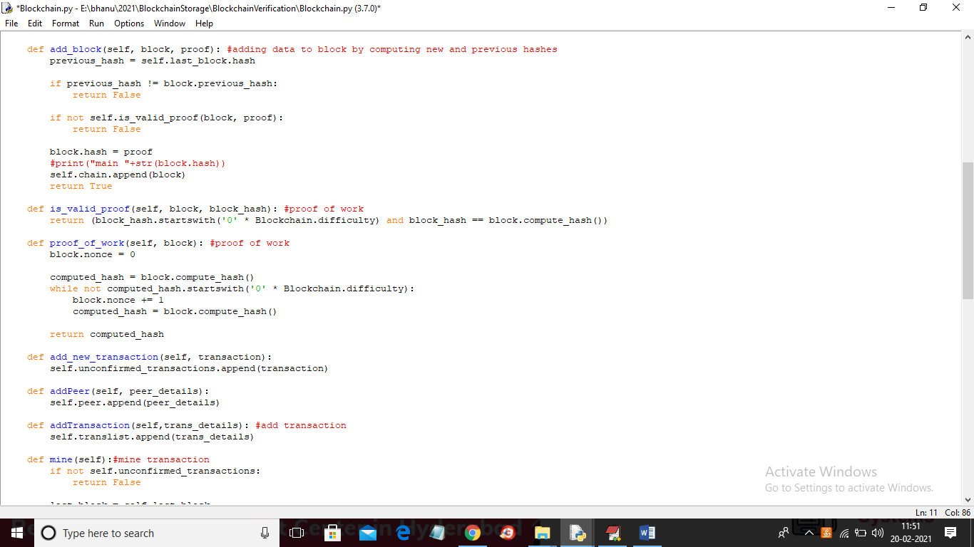

To implement this project we have taken some bar codes and this bar codes stored inside ‘original_barcodes’ and you can use those or you own ‘barcodes’ to upload to Blockchain and below is the bar codes screen shots

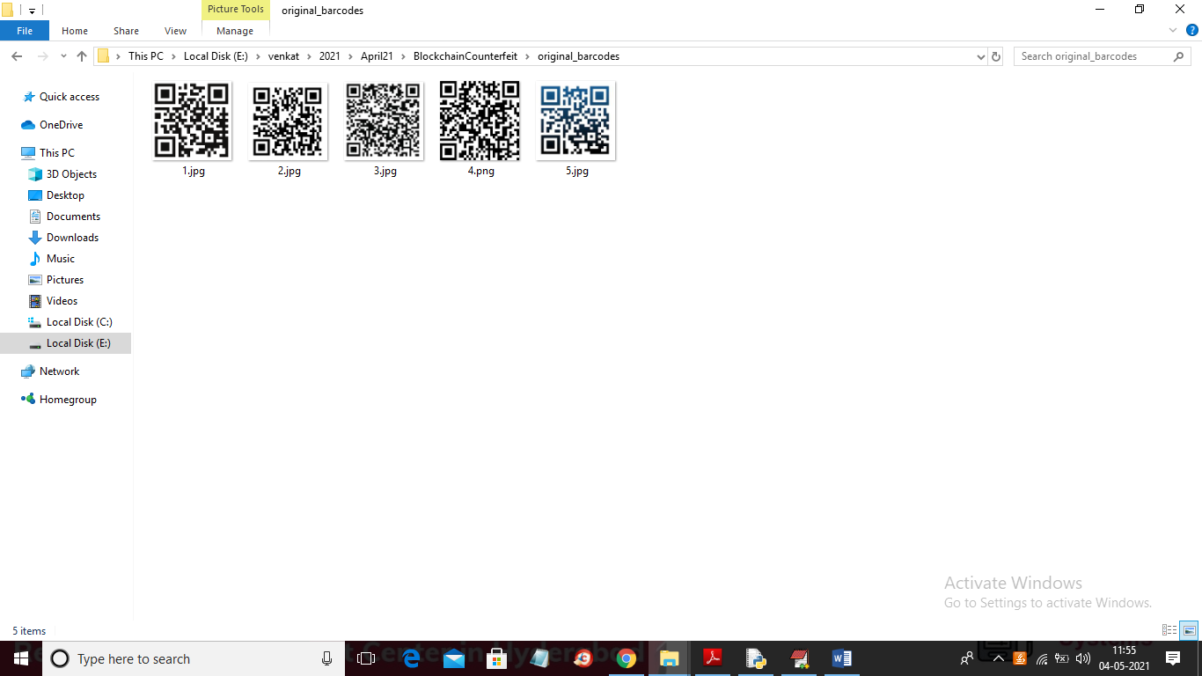

Will use above bar codes to store product details in Blockchain

SCREEN SHOTS

To run project double click on ‘run.bat’ file to get below screen

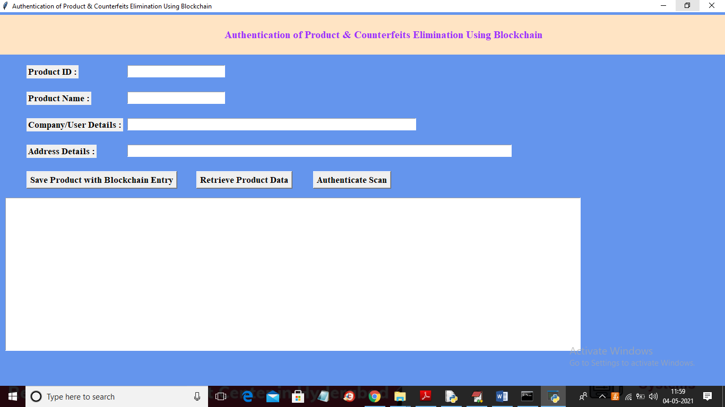

In above screen enter product details and then click on ‘Save Products with Blockchain Entry’ button to store product details in Blockchain

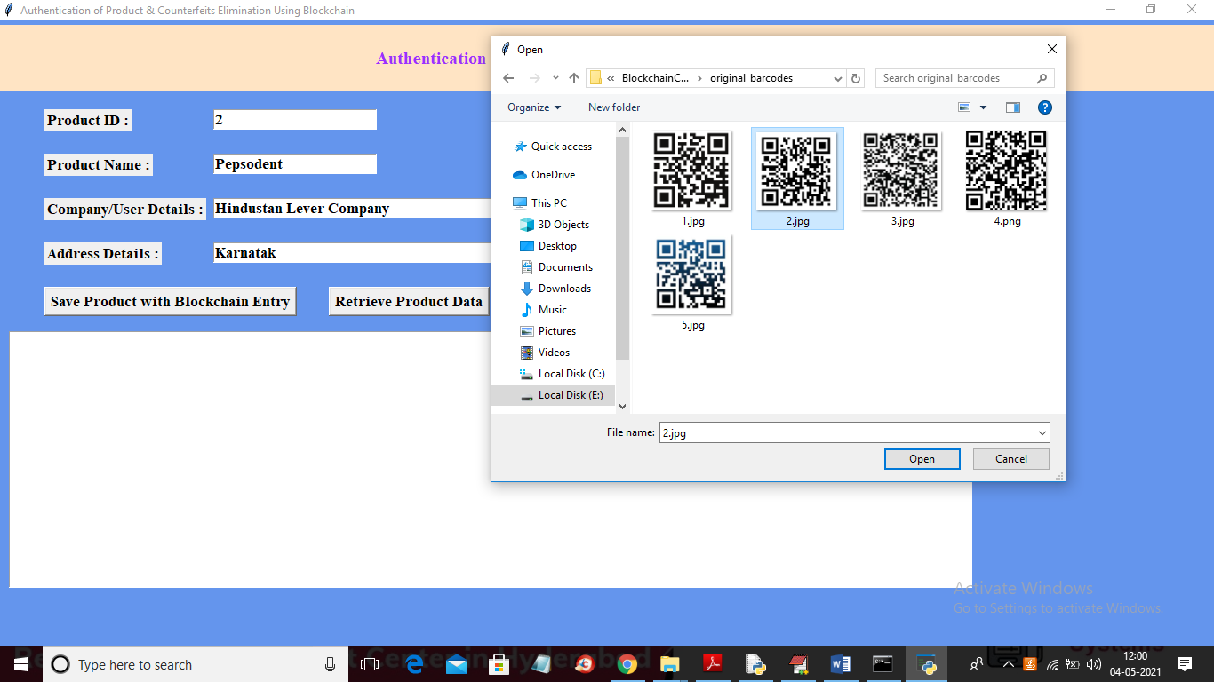

In above screen I entered product details and then selecting and uploading associated BARCODE image and then click on ‘Open’ button to get below result

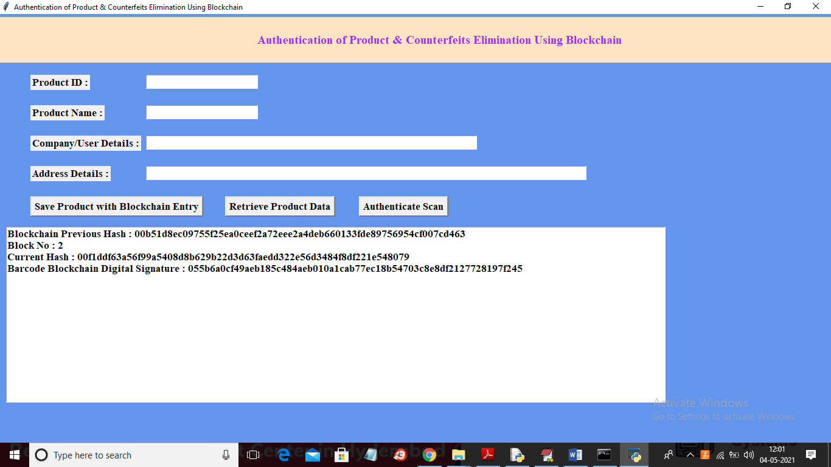

In above screen Blockchain generated new Block with id 2 and we can see Blockchain hash code of old and new transaction with uploaded bar code digital signature and all this details will saved inside Blockchain and now to search product details click on ‘Retrieve Product Data’ button to get below details

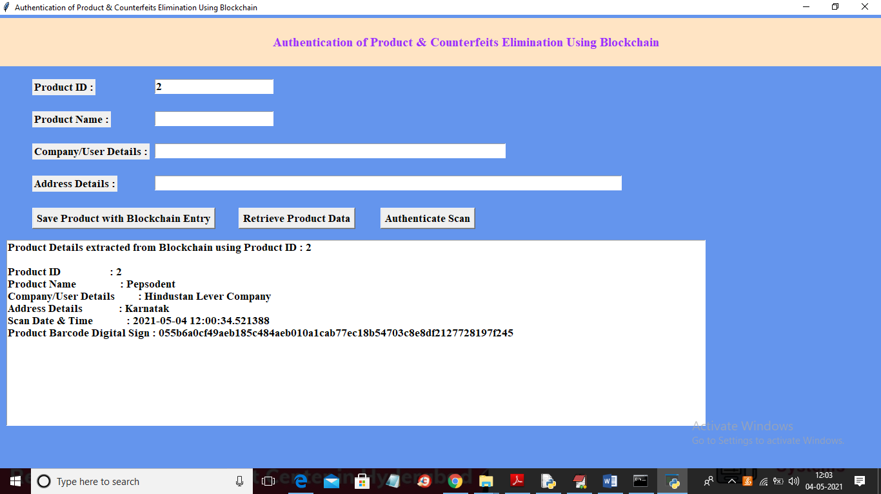

In above screen I entered product id as 2 and then click on ‘Retrieve Product Data’ button to get above details. Now click on ‘Authenticate Scan’ button to upload product Barcode and then Blockchain will match this uploaded Barcode signature with available stored signatures and if match found then authentication will be successful else failed

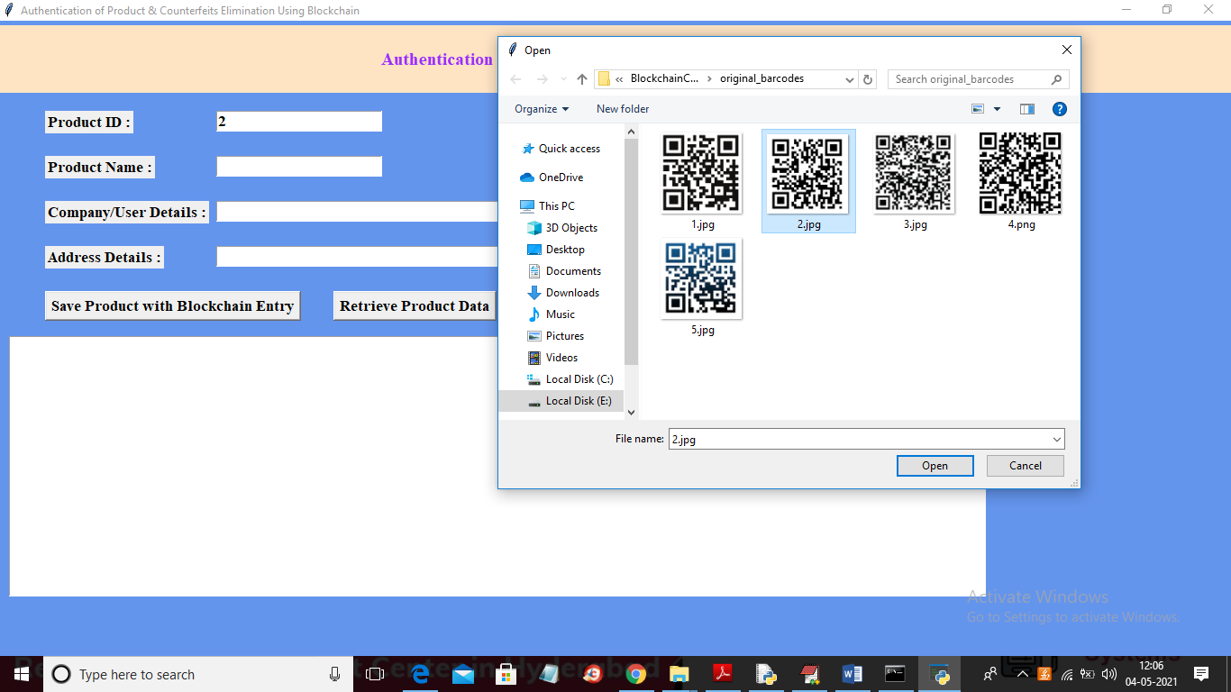

In above screen I am selecting and uploading ‘2.jpg’ file and then click on ‘Open’ button to get below result

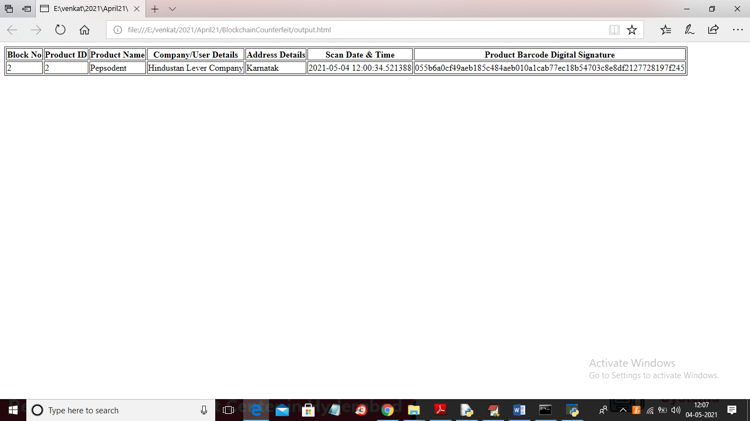

In above screen in browser author can see all authentication details uploaded product bar code. Now check with fake barcode by uploading from ‘fake bar code’ folder

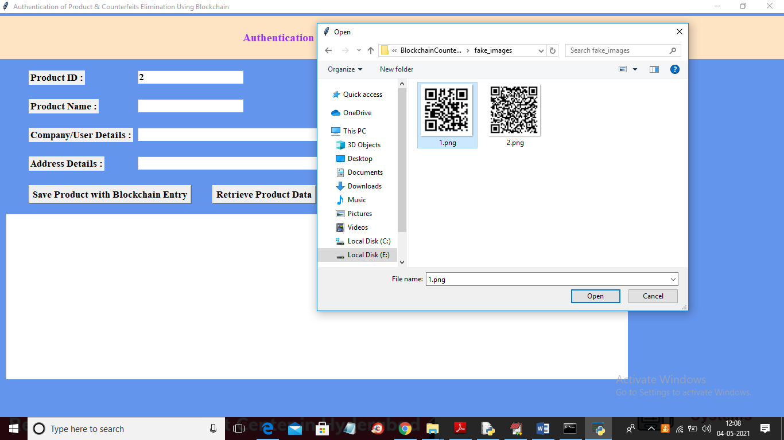

In above screen uploading barcode from fake folder and below is the result

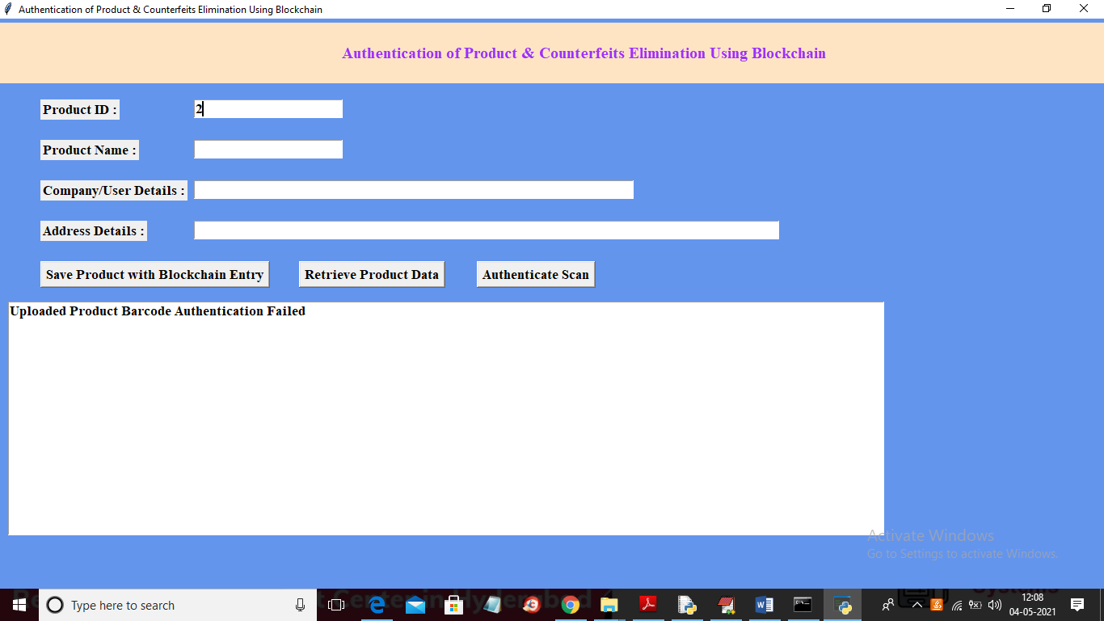

In above screen in text area we can see uploaded bar code authentication failed.